Gypsum Belt-Filter Cake Recognition
Automated Valid / Invalid Detection from a Plant Camera Feed
Final Project Report — Version 2 (final results)
AI Expert — Final Project Course
Yaron Conroy
2026-09-24
Code repository: github.com/yaronconroy-del/picture-recognition-gypsum

Table of Contents
Table of Contents 2
1. Executive Summary 4
2. Introduction 5
2.1 Problem Statement 5
2.2 Background and Motivation 5
2.3 Related Work 5
3. Dataset 7
3.1 Class Distribution 7
3.2 Sample Images 7
3.3 Known Dataset Characteristics 8
3.4 The Day/Night Anomaly 8
3.5 Exploratory Data Analysis 9
4. Methodology 10
4.1 Preprocessing 10
4.2 Leakage-Safe Train/Test Splitting 10
4.3 Model Architecture and Fine-Tuning Strategy 10
4.4 Handling Class Imbalance 11
4.5 Training Configuration 11
5. Experiments and Results 12
5.1 Stage 1 — Baseline: Lite vs. Extended Label Scheme 12
5.2 Stage 2 — No-Empty Scheme (Round 2) 12
5.3 Label-Scheme Decision 14
5.4 Stage 3 — Threshold, ROC, PR, and Calibration Analysis 14
5.5 Stage 4 — Ensemble, Test-Time Augmentation, and Calibration 15
5.6 Stage 5 — Live Demo Scripts 16
5.7 Stage 6 — Finding: A Mislabeled Photo Was Costing Accuracy 17
6. Decision Log 19
7. Business Case and Value Estimate 20
7.1 Yield Loss 20
7.2 Downtime (Equipment Damage) 20
7.3 Combined Value Estimate 20
8. Conclusions 21
9. Limitations 21
10. Further Directions 22
10.1 Near-Term 22
10.2 Full-Scale Pilot Roadmap 22
11. Appendix 23
A. Repository Structure 23
B. References 23

1. Executive Summary
This project builds an image classifier that looks at a single camera frame of a gypsum belt filter — part of a wet-process phosphoric acid production line — and automatically determines whether the filter cake is VALID (properly dewatered) or INVALID (wet gypsum), so that filtration problems can be caught automatically instead of relying solely on intermittent manual inspection.
Wet gypsum causes two measurable costs: lost, unrecovered phosphoric acid (yield loss) and downstream equipment damage (downtime). Automating detection instead of relying on manual checks is estimated to recover roughly $1.48M–$2.21M per year, at a 10–15% recovery rate against a combined annual exposure of approximately $14.76M — the full calculation, with every assumption stated explicitly, is in Section 7.
Working from a small dataset of 176 labeled photographs, the project systematically compared four label schemes, three train/test split ratios, cross-validation, class-imbalance handling, decision-threshold tuning, and ensemble techniques — 22 individually reasoned experiments in total, each building on the last. The best-performing and operationally simplest model, a 4-class scheme that folds “empty filter” into “invalid” (no-empty split), was selected based on converging statistical evidence (cross-validation accuracy, ROC AUC, PR AP) and an independent operational argument: a deployed model does not need to recognize “empty” at all, since the operator empties the filter themselves and already knows it.
Final result: the promoted model reaches 80.3% ± 0.4 cross-validation accuracy, 80.7% invalid recall, and ROC AUC 0.882. Along the way, a manual full-resolution review of every day/night label found one photo filed under the wrong lighting class (a “valid, day” photo sorted as “valid, night”). That single label error had been costing the promoted model accuracy: with it corrected, cross-validation accuracy rose from 77.4% to 80.3%, invalid recall from 71.1% to 80.7%, and ROC AUC from 0.818 to 0.882 (Section 5.7). All results in this report come from the final full run on the corrected data.
The project also produced two working local scripts — a single-photo classifier and a simulated live-feed watcher — and an honest accounting of what remains open: the “day”/“night” labels do not actually correspond to time of day, and their true meaning is still unresolved; the results rest on 176 photos and a single random seed; and a real camera/alerting integration remains to be built. These, and a roadmap for a full-scale plant pilot, are set out in Sections 9 and 10.

2. Introduction

2.1 Problem Statement
A fixed industrial CCTV-style camera is mounted above a gypsum belt filter on a phosphoric-acid production line. Filtration quality is currently checked by manual visual inspection, which is inherently intermittent (an operator cannot watch the feed continuously) and inconsistent (judgment varies between operators and shifts). The goal of this project is an image classifier that looks at a single camera frame and determines whether the cake is VALID or INVALID, automatically and continuously — closing the gap between when a problem happens and when it is noticed.
This is a proxy for a real yield-loss and equipment-damage problem, not a cosmetic visual check: the visual cracking/patchiness that marks a cake as “invalid” is how wet, poorly-dewatered gypsum looks on camera.

2.2 Background and Motivation
This project comes directly from a real process at the author's plant, a wet-process phosphoric acid producer: phosphate rock reacts with sulfuric acid to produce phosphoric acid, with gypsum as a by-product. The gypsum still carries residual phosphoric acid, so it is washed with water and then dewatered on the belt filter this project's camera watches, to recover as much phosphoric acid as economically possible before the gypsum is discarded.
“Invalid” means wet gypsum — the cake did not dewater properly. This has two separate costs:
1. Yield loss — phosphoric acid trapped in gypsum that is still wet is lost with the discarded gypsum. Every 1% of phosphoric acid remaining in the gypsum costs roughly $2,000/hour. On an annual basis this typically runs to a loss equivalent to about 3% of throughput, with bad-filtration episodes accounting for roughly 6% of downtime.
2. Equipment damage / downtime — wet gypsum can damage downstream equipment, adding a further ~3% of annual downtime on top of the yield-loss figure above.
The full monetized business case, with every assumption stated explicitly, is worked through in Section 7.

2.3 Related Work
A short survey of existing approaches to similar problems was carried out to check this project's plan against established practice rather than reinventing it from scratch. No published work was found on this exact equipment (gypsum belt filter cake inspection specifically); the closest matches are the general “surface/assembly defect via transfer-learned CNN” literature summarized below, which is why this project's approach follows that pattern.
- Transfer learning from ImageNet-pretrained CNNs is the standard approach for small industrial visual-inspection datasets. A 2024 systematic review of CNN-based surface-defect detection found transfer learning used in 83% of studies surveyed, specifically because training a CNN from scratch needs a dataset far larger than most factories can realistically label. This directly matches this project's choice: MobileNetV2, transfer-learned rather than trained from scratch, on a 176-image dataset that would never support training a CNN from zero.
- Class imbalance between “normal” and “defect” is treated as the norm, not the exception, in industrial defect detection, because in a working process defects genuinely are rarer than normal output. This project's “empty filter” class (8 of 176 images, 4.5%) sits in the same range as examples cited in the literature, and the standard mitigations the literature points to — cost-sensitive/class-weighted loss and resampling — are exactly what this project tried, including the honest negative finding that resampling added nothing once weighted loss was already in place.
- Reported accuracy in comparable published work is high (often 95%+), but on datasets one to three orders of magnitude larger than this one — e.g. a transfer-learning assembly-defect inspection system reaching 98.67% accuracy was trained on thousands of labeled images per station, not 176 total across 4–5 classes. This project's own numbers (~80% cross-validation accuracy on the leading scheme) should be read against that gap, not against the field's best-case numbers.
References are listed in Appendix B.

3. Dataset
The dataset consists of 176 photographs captured by the plant's fixed camera and originally exported via WhatsApp (filenames followed the WhatsApp Image <date> at <time> (<n>).jpeg pattern). They were manually sorted into folders that act as class labels, then renamed to random IDs (img_<id>.jpeg) with a manifest mapping back to the originals, so filenames cannot leak label information.

3.1 Class Distribution
Class | Meaning | Condition | Time of Day | # Images
תקין יום | Valid — day | Normal/OK cake | Day | 63
תקין לילה | Valid — night | Normal/OK cake | Night | 29
לא תקין יום | Invalid — day | Abnormal/faulty cake | Day | 42
לא תקין לילה | Invalid — night | Abnormal/faulty cake | Night | 34
מסנן ריק | Empty filter | No cake on filter | N/A | 8

Counts are after the day/night label correction described in Section 5.7 (one photo moved from valid-night to valid-day; originally 62 / 30).
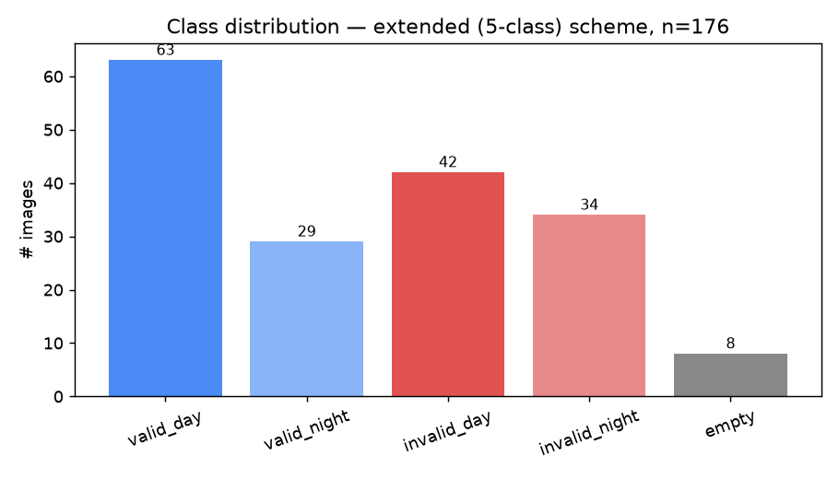
Figure 1. Class distribution, extended (5-class) scheme, corrected labels, n = 176.

3.2 Sample Images
Figure 2 shows four random examples per class. The burned-in timestamp overlay (top-right) and the night floodlight glare are both visible; note that at least one “valid, day” sample also shows a bright glare spot, which foreshadows the day/night finding in Section 3.4.
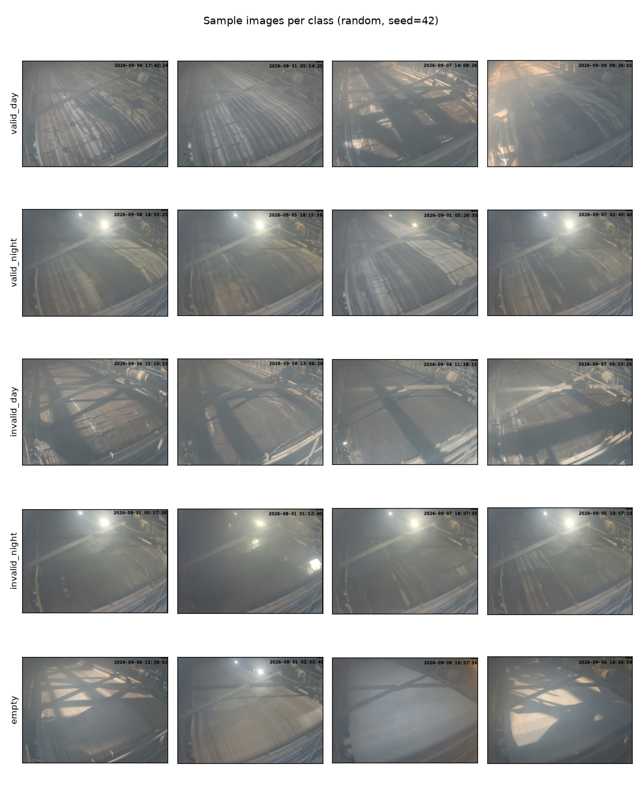
Figure 2. Random sample images per class (seed = 42).

3.3 Known Dataset Characteristics
- Class imbalance — “empty filter” has only 8 images vs. 30–62 for the other classes.
- Burned-in timestamp overlay — every image has a date/time stamp in the top-right corner, masked out before training so the model cannot key off it.
- Steam/dust obstruction — the process itself produces mist that partially obscures the filter in many shots; this is signal the model needs to be robust to, not noise to remove.
- Fixed camera angle — all images come from the same mounted camera, which simplifies the problem but means the model may be specific to this one installation.
- Source quality — images are WhatsApp exports (recompressed JPEGs), not original camera resolution.

3.4 The Day/Night Anomaly
Cross-referencing the manifest's recovered original capture timestamps against the day/night folder each photo came from turned up something unexpected: day- and night-labeled photos are interleaved within the same few seconds of each other, not hours apart. Example, from 2026-09-09:
11:29:43 day
11:29:47 night
11:29:49 day
11:29:50 day
11:29:56 night
All around 11:29 AM — clearly not solar daytime vs. nighttime. Whatever these two folders actually distinguish (two camera angles, flash vs. no flash, or a labeling judgment call made while manually sorting), it is not literal time-of-day.
This was checked a second way in Section 3.5's exploratory analysis, with the same conclusion. What the labels mean remains an open question (Section 9); whether each photo was sorted consistently was checked separately, photo by photo (Section 5.7).

3.5 Exploratory Data Analysis
A standalone script (eda.py) examined the raw dataset directly — not model outputs — producing the class-distribution and sample-grid figures above, plus a brightness comparison and an image-size check.
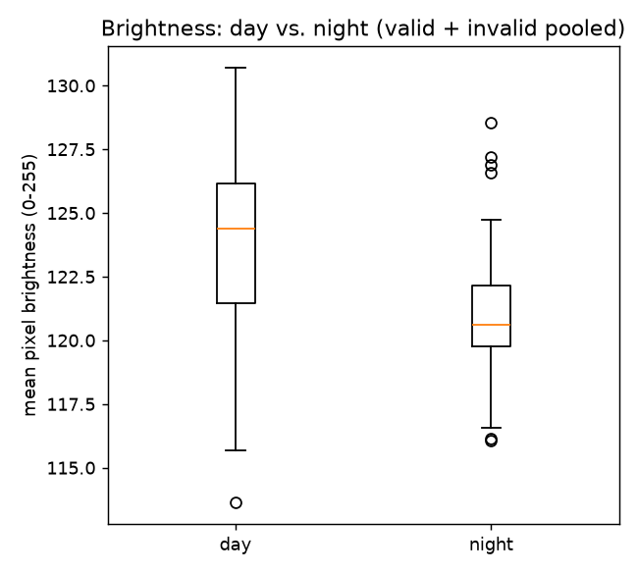
Figure 3. Mean per-image pixel brightness, day vs. night (valid + invalid pooled).
- Brightness finding (computed on the original labels): day and night are barely different on this measure — 123.6 (day, n=104) vs. 121.0 (night, n=64) mean brightness, heavily overlapping distributions. This is a second, independent line of evidence that whatever “day”/“night” actually encodes, it is not a simple global brightness difference — the floodlight's effect is a local hot spot, not a shift in the whole frame's average tone.
- Image size check: no two images in the dataset share identical pixel dimensions (176 distinct sizes, all within a narrow band around ~1150–1185 × 825–875 pixels). This confirms the WhatsApp re-encoding theory and confirms that resizing every image to a consistent resolution during preprocessing is necessary, not just conventional.

4. Methodology

4.1 Preprocessing
- Timestamp overlay masked out (top 10% of the frame) so the model cannot key off the burned-in clock.
- Images resized to 240×240 then center-cropped (eval) or randomly cropped (train) to 224×224, the standard ImageNet input size, then normalized to ImageNet mean/std.
- Train-time augmentation: color jitter (brightness/contrast/saturation), small random rotation (±6°), and random crop — no horizontal flip, since the camera's framing (motor always upper-right) is not mirror-symmetric in real footage.

4.2 Leakage-Safe Train/Test Splitting
Photos taken seconds apart are near-duplicates. Splitting by individual image would let near-identical frames end up in both train and test, inflating the apparent accuracy. Instead, the manifest's recovered original capture timestamps were used to group photos into “sessions” (photos within 120 seconds of each other), and splits were made at the session level — an entire session goes to train or to test, never split across both.
- Three split ratios were tested for every label scheme: 80/20, 75/25, and 70/30.
- K-fold cross-validation was also run per scheme, with K auto-capped to whatever the scarcest class's independent session count actually supports (this varied from 2 to 3 depending on scheme — not every scheme could support the same K).
- The scarce “empty” class was floored at ≥ 3 training images regardless of split ratio.

4.3 Model Architecture and Fine-Tuning Strategy
Every model in this project uses the same architecture — MobileNetV2, pretrained on ImageNet — so that differences in results are attributable to the label scheme and split, not to architecture changes. MobileNetV2 consists of 19 feature blocks (1 stem convolution, 17 inverted-residual bottleneck blocks, and 1 head convolution), 52 convolutional layers in total, followed by a classifier head.
Only the last block (the head convolution) and a newly-added classifier layer (Linear(1280 → num_classes)) are unfrozen and trained; everything earlier stays frozen at its pretrained weights. This choice is dataset-size-driven, not a fixed rule:
- Overfitting risk: MobileNetV2 has ~3.4M parameters. Fully fine-tuning all of it on 176 images (some classes as few as 8) would let the network memorize the training set instead of generalizing. Freezing most of the network acts as a strong regularizer.
- Early/mid layers are already general-purpose: pretrained on 1.2M ImageNet images, they have learned edges, textures, and shapes that transfer to almost any image task, this one included.
- Only the last block is specific enough to be worth adapting: the deeper a layer sits, the more it encodes concepts specific to the original task. Unfreezing just the last block lets the model reshape its final representation toward “cake texture is even vs. cracked/patchy” without touching the general-purpose feature extractors underneath.
- Compute: this project trains 17 configurations (23 counting cross-validation folds individually), mostly on CPU — fewer trainable parameters means faster training across that many runs.
- This matches the related-work finding in Section 2.3: transfer learning with a mostly-frozen backbone is standard practice specifically because industrial defect-detection datasets are usually small. With a much larger database (Section 10.2), unfreezing more blocks would likely improve on today's results further.

4.4 Handling Class Imbalance
The “empty” class has only 8 of 176 images (4.5%). Two mitigations were tried:
- Class-weighted CrossEntropyLoss (inverse-frequency weighting) — used in every training run.
- WeightedRandomSampler (oversampling) on top of the weighted loss — tested once as a variant. In the original run it made no difference (identical metrics); in the final run it scored one test image better (7/10 vs. 6/10) — within noise on a 10-image test set. Given the loss weighting already existed, resampling the same ~6 empty training images more often did not add new information; more real empty photos would be needed for further improvement.

4.5 Training Configuration
One fixed configuration was held constant across every comparison in this project, so that only one variable (label scheme, split ratio, or technique) changes at a time:
Parameter | Value
Backbone | MobileNetV2 (ImageNet-pretrained)
Fine-tuning | Last block + new classifier only (Section 4.3)
Optimizer | Adam, lr = 1e-3
Epochs | 10
Batch size | 16
Loss | Class-weighted CrossEntropyLoss
Random seed | 42 (fixed throughout)
Environment | Final run: local CPU (~15 min for all 23 trainings); the same notebook runs unchanged on Google Colab (GPU)

5. Experiments and Results
This section walks through the project's experiments in the order they were run, each one building on the previous stage's findings. All cross-validation (“CV”) numbers pool every fold's held-out predictions before scoring, and are the most trustworthy read in every table below — single train/test splits use very small test sets (as few as 10–16 images) and should be read with caution.
Every number in Sections 5.1–5.5 comes from the final full run of the consolidated notebook (full_pipeline.ipynb: all 17 configurations, 23 trainings, 10 epochs each) on the day/night-corrected dataset. Section 5.7 compares them with the earlier run on the uncorrected labels.

5.1 Stage 1 — Baseline: Lite vs. Extended Label Scheme
The first comparison tested whether simplifying day/night into a single label (the “lite”, 3-class scheme: valid / invalid / empty) costs anything against keeping day and night as separate classes (the “extended”, 5-class scheme). The same fixed configuration (Section 4.5) was swept across all three split ratios plus cross-validation, and one oversampling variant.
Variant | Accuracy | Val Loss | Macro F1 | Invalid Recall
Lite, 80/20 | 0.600 | 0.485 | 0.450 | 0.600
Lite, 75/25 | 0.851 | 0.440 | 0.453 | 0.400
Lite, 70/30 | 0.600 | 0.346 | 0.391 | 0.424
Lite, 3-fold CV | 0.633 ± 0.027 | 0.418 | 0.540 | 0.433 ± 0.124
Lite, 80/20 + oversampling | 0.700 | 0.489 | 0.519 | 0.800
Extended, 80/20 | 0.632 | 0.359 | 0.415 | 0.643
Extended, 75/25 | 0.717 | 0.419 | 0.465 | 0.714
Extended, 70/30 | 0.698 | 0.382 | 0.439 | 0.571
Extended, 2-fold CV | 0.676 ± 0.049 | 0.674 | 0.642 | 0.499 ± 0.144

Findings:
- Extended (5-class) beat lite (3-class) in cross-validation — extended 67.6% ± 4.9 vs. lite 63.3% ± 2.7 accuracy, with higher macro F1 (0.642 vs. 0.540) and invalid recall (0.499 vs. 0.433) — and on two of the three split ratios. Lite's one high single-split score (85.1% on 75/25) is misleading: its invalid recall there is only 0.400 and macro F1 0.453, i.e. it scored mostly by calling valid photos valid.
- No split ratio was uniformly best for both schemes — with this little independent data, which scheme is used matters more than the exact ratio.
- The oversampling variant scored one test image better than plain lite 80/20 (70% vs. 60%) — on a 10-image test set that is within noise, so it is not read as a real gain.

5.2 Stage 2 — No-Empty Scheme (Round 2)
A fourth label scheme was then tried: redefining “empty filter” as a kind of invalid rather than its own class, on the reasoning that an empty filter is arguably a fault state too, not a neutral third option. The 8 empty-filter photos were manually reassigned to invalid-day or invalid-night (6 day, 2 night, judged by eye), and read at two granularities: collapsed (2-class: valid/invalid) and split (4-class: valid_day / valid_night / invalid_day / invalid_night).
Variant | Accuracy | Val Loss | Macro F1 | Invalid Recall
No-empty collapsed, 80/20 | 0.818 | 0.578 | 0.804 | 0.750
No-empty collapsed, 75/25 | 0.833 | 0.483 | 0.747 | 0.750
No-empty collapsed, 70/30 | 0.547 | 0.589 | 0.508 | 0.286
No-empty collapsed, 3-fold CV | 0.700 ± 0.147 | 0.528 | 0.677 | 0.561 ± 0.255
No-empty split, 80/20 | 0.750 | 0.405 | 0.709 | 0.692
No-empty split, 75/25 | 0.759 | 0.423 | 0.739 | 0.765
No-empty split, 70/30 | 0.741 | 0.499 | 0.722 | 0.765
No-empty split, 2-fold CV | 0.803 ± 0.004 | 0.340 | 0.791 | 0.807 ± 0.016

Findings — the headline result of the whole optimization effort:
- No-empty split (4-class) beat every scheme tried in this project, on cross-validation: 80.3% ± 0.4 accuracy and 80.7% ± 1.6 invalid recall, vs. the next best, no-empty collapsed at 70.0% ± 14.7 and extended at 67.6% ± 4.9. It is both higher and has by far the tightest spread of any scheme.
- No-empty collapsed (2-class) is not trustworthy despite its high single-split numbers: its CV variance is huge (±14.7 points across its three folds), almost certainly because collapsing day/night here throws away a real signal that the split version keeps.
- The “empty = invalid” reframing appears to genuinely help, not just shuffle the same information around — likely because the model no longer has to learn a 3rd/5th class from only 6–8 examples, and “empty” and “invalid” probably share real visual similarity (bare or torn filter surface) that the model can exploit once they are merged.
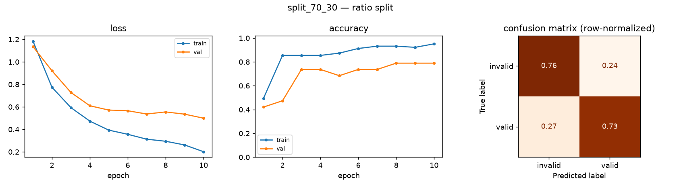
Figure 4. Promoted model (no-empty split, 70/30): loss and accuracy curves (train vs. val) and test confusion matrix.
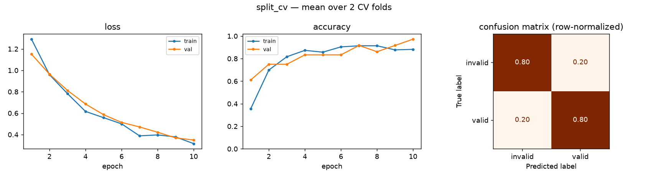
Figure 5. No-empty split, 2-fold CV: curves and pooled confusion matrix over both held-out folds.

5.3 Label-Scheme Decision
On the original (uncorrected) labels, extended and no-empty split were close together on one metric (ROC AUC), which initially looked like a genuine toss-up. The resolution came from recognizing a methodological flaw: that comparison scored each scheme against its own definition of “invalid” — a slightly different question per model. Putting both schemes on the same ground truth (the no-empty definition) in the same run (Section 5.5) resolved it. In the final run the result is even clearer: no-empty split leads on every metric even on each scheme's own ground truth (Section 5.4), and on the shared ground truth it wins ROC AUC 0.882 vs. 0.782 and PR AP 0.826 vs. 0.704.
Beyond the numbers, there is a stronger operational reason to fold “empty” into “invalid” rather than keep it as its own class, identified during review with the plant engineer:
1. The empty-filter dataset is tiny (8 of 176 images) — the statistical reason already covered above.
2. A live model does not need to detect “empty” at all — the operator empties the filter themselves, so they already know it is empty; the camera has no information advantage there. Asking the model to spend capacity distinguishing “empty” from “invalid” is solving a problem the operator does not have.
3. The natural production design follows from this: the model gets toggled off when the operator empties the filter, and toggled back on once filtration resumes — “empty” is an operator-controlled state to route around, not a class the vision model needs to recognize on its own.
Decision: the no-empty split (4-class) scheme — valid_day / valid_night / invalid_day / invalid_night — is the project's chosen scheme. Lite and no-empty collapsed were ruled out earlier by every analysis. This is the best-supported hypothesis given everything tried, not a production-validated result: the dataset is still 176 photos with a single random seed, run mostly on CPU.

5.4 Stage 3 — Threshold, ROC, PR, and Calibration Analysis
Every training run up to this point decided valid-vs-invalid with a bare argmax() — an implicit 0.5 probability cutoff that was never chosen deliberately or checked. All 23 individual trainings across the project (every ratio split × every cross-validation fold, all 4 schemes) were re-analyzed with full class probabilities instead of just the winning class, computing a ROC curve and AUC, a precision-recall curve and average precision (AP), a calibration curve, and two candidate best thresholds for flagging “invalid”: Youden's J (balances both error types) and an F1-optimal threshold (tuned specifically for the invalid class).
Config (CV = pooled) | ROC AUC | PR AP | Youden Threshold | F1-Optimal Threshold
Lite, CV | 0.763 | 0.653 | 0.178 | 0.109
Extended, CV | 0.797 | 0.689 | 0.299 | 0.299
No-empty collapsed, CV | 0.723 | 0.671 | 0.375 | 0.173
No-empty split, CV | 0.882 | 0.826 | 0.493 | 0.366

Findings:
- The default 0.5 cutoff has been under-flagging real faults the whole time. In all 17 configurations, both optimal thresholds (Youden and F1-optimal) are below 0.5. For the promoted model they are 0.49 and 0.37, giving a recommended operating range of about 0.37–0.49. Switching from the untuned default to a tuned threshold would flag more real invalid cases as invalid, at the cost of a few more false alarms — a trade worth making, since a missed invalid costs more than a false alarm.
- On pure invalid-vs-not ranking quality (ROC AUC), no-empty split now also leads clearly (0.882 vs. extended's 0.797). On the original labels this was the one metric where extended had edged ahead (0.837 vs. 0.818) — the toss-up described in Section 5.3. With the label correction (Section 5.7) that reversal is gone: accuracy, invalid recall, ROC AUC and PR AP all point the same way.
- Lite and no-empty collapsed are weaker on both accuracy and ranking quality — consistent evidence across two different kinds of analysis that they are the two schemes to rule out first.
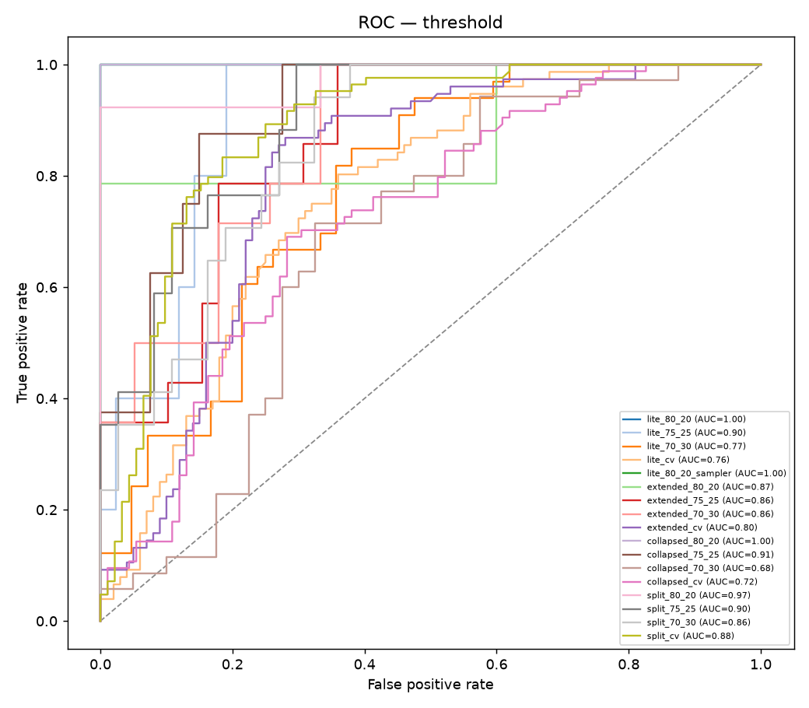
Figure 6. ROC curves, all 17 individual training configurations (final run).

5.5 Stage 4 — Ensemble, Test-Time Augmentation, and Calibration
Three ways to push further were tried on the two closest competitors from Section 5.4 (extended CV vs. no-empty split CV): (1) averaging the two schemes' P(invalid) per image, each from its own properly held-out cross-validation fold model; (2) test-time augmentation (TTA), averaging the softmax over 6 mildly-augmented views per image at inference instead of one center crop; and (3) Platt-scaling calibration on top of the ensemble+TTA score. Ground truth throughout is the no-empty definition of “invalid” for every row, which is why this table puts both schemes on the same fair comparison referenced in Section 5.3.
Variant | ROC AUC | PR AP
Extended alone | 0.782 | 0.704
No-empty split alone | 0.882 | 0.826
Ensemble (extended + split, averaged) | 0.846 | 0.774
Ensemble + TTA | 0.862 | 0.795
Ensemble + TTA + calibration | 0.862 | 0.795

Finding, reported straight, not spun: none of the three techniques beat the single best model. No-empty split alone (0.882 AUC / 0.826 AP) outperforms every ensemble variant. A plain 50/50 average pulled the stronger model down toward the weaker one rather than lifting it; TTA recovered part of that (0.862 / 0.795) but not all; calibration, as expected for a monotonic rescaling, left both ranking metrics unchanged, only improving probability quality, not discrimination. This is a useful negative result: with two models this close in quality but one clearly ahead, naive averaging is not automatically better than just using the better model. A confidence-weighted ensemble (weighting no-empty split more heavily than extended, rather than 50/50) is the natural next thing to try; it was not implemented here.
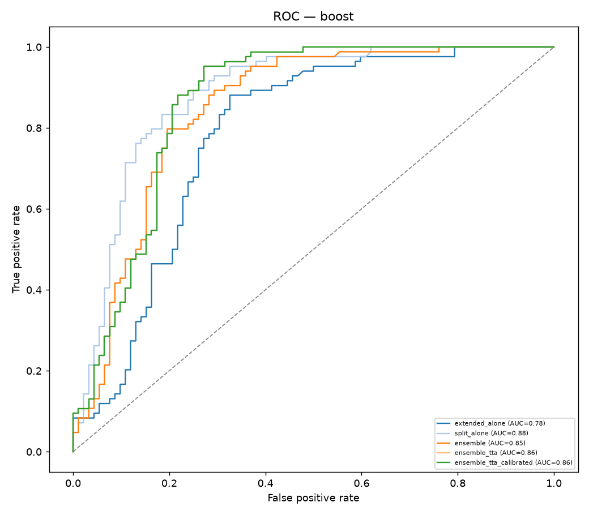
Figure 7. ROC curves — ensemble/TTA/calibration variants vs. each model alone (final run).

5.6 Stage 5 — Live Demo Scripts
Two local scripts were built to demonstrate the classifier working end-to-end, both reusing the exact same preprocessing and model-loading code so there is no drift between what was evaluated and what runs live.
- predict.py — classifies one photo from the command line, printing the predicted class, confidence, and an operator-facing VALID/INVALID call (an “empty” prediction counts as INVALID, per the Section 5.3 decision). It automatically loads the promoted no-empty-split model produced by the final run, falling back to the extended model if it is missing. Spot-checked with the promoted model on an invalid_day photo: INVALID, 61.2% confidence, correct. (Earlier checks with the extended model: a valid_day photo at 89%, correct; an invalid_night photo at 98%, correct; and a valid_night photo at a lower-confidence 47%, with empty and invalid_night close behind.)
- watch_camera_feed.py — a simulated live feed: watches a folder for new photos and classifies each one within a few seconds of it appearing, printing an alert line whenever the call is INVALID. This is explicitly a simulation, not a real camera integration — a real deployment would need an actual frame source (an RTSP stream, or the camera's own image export) and a real alerting channel (SMS, dashboard, or log file), neither of which is decided yet. Tested locally with a valid and an invalid sample photo; both were classified correctly and the alert fired correctly on the invalid one.

5.7 Stage 6 — Finding: A Mislabeled Photo Was Costing Accuracy
Rather than keep treating the day/night ambiguity (Section 3.4) as untouchable, every one of the 168 day/night-labeled photos (“empty” excluded — it is not split by day/night) was reviewed against the one reliable visual signature found in the exploratory analysis: night photos show a small, sharp, near-saturated floodlight glare; day photos show flatter, diffuse haze with no sharp point source. Photos were first reviewed on contact sheets, and every doubtful one was then examined individually at full resolution before any decision. Several photos that looked wrong as thumbnails turned out to have the floodlight clearly visible when zoomed in, and were left alone; anything still ambiguous stayed as originally labeled.
Result: exactly one confident mismatch out of 168 — img_dfa74e21.jpeg, filed as “valid, night” but showing flat daylight-style lighting with no floodlight glare anywhere in the frame. It was moved to “valid, day” (same validity, only the lighting class changed). The originals were left untouched; corrected copies of the dataset folders were made, and the final run was trained on those.
Promoted model (no-empty split, CV) | Before (original labels) | After (corrected)
Accuracy | 77.4% ± 1.9 | 80.3% ± 0.4
Invalid recall | 71.1% ± 5.4 | 80.7% ± 1.6
ROC AUC (own ground truth) | 0.818 | 0.882
PR AP (own ground truth) | 0.768 | 0.826
ROC AUC (shared ground truth, Section 5.5) | 0.852 | 0.882

Control / other schemes (CV accuracy) | Before | After
Lite (no day/night classes) | 63.3% | 63.3%
No-empty collapsed (no day/night classes) | 70.8% | 70.0%
Extended (keeps day/night classes) | 72.3% | 67.6%

Findings:
- The mislabeled photo had been costing the promoted model accuracy. With it fixed, cross-validation accuracy rose about 3 points, invalid recall about 10 points, and the fold-to-fold spread tightened sharply (±1.9 → ±0.4 accuracy, ±5.4 → ±1.6 recall).
- Control check: the two schemes that do not use day/night at all (lite and no-empty collapsed) reproduce almost exactly between the two runs. That is what makes it reasonable to attribute the split scheme's gain to the label fix rather than to run-to-run noise.
- Not every scheme improved: extended, which also keeps day/night as classes, dropped (CV accuracy 72.3% → 67.6%, ROC AUC 0.837 → 0.797). With 2-fold CV on this little data, moving one photo also changes which session lands in which fold. Extended was already the runner-up, so this does not affect the decision.
- Why one photo out of 176 matters this much: with only 2 folds and a few dozen independent sessions, one wrong label sits in the training data of one fold and the test data of the other, so it both teaches the model a wrong example and is scored as an error.
- Net: the Section 5.3 decision stands, now on stronger evidence, and the review confirmed that the original manual sort was generally reliable on the lighting cue (1 error in 168).

6. Decision Log
A consolidated record of every major decision made over the course of the project, in order, with the reasoning behind each one.
# | Decision | Reasoning
1 | Framework: PyTorch + transfer learning (MobileNetV2) | Small dataset (176 images) cannot support training a CNN from scratch; transfer learning is standard practice for this data regime (Section 2.3).
2 | Only the last backbone block + classifier are fine-tuned | Overfitting risk on 176 images vs. 3.4M parameters; early/mid layers are already general-purpose (Section 4.3).
3 | Leakage-safe splitting by capture session, not by image | Photos seconds apart are near-duplicates; per-image splitting would leak information across train/test.
4 | Class-weighted loss for the imbalanced “empty” class | Standard mitigation for imbalance; a WeightedRandomSampler variant was also tried and added nothing beyond noise.
5 | Extended (5-class) scheme preferred over lite (3-class) | Extended beat lite on every split ratio and in cross-validation (Section 5.1).
6 | No-empty split (4-class) adopted as the final label scheme | Wins on every metric once both schemes are compared against the same ground truth (Section 5.3), plus a strong operational argument: a live model does not need to detect “empty” at all.
7 | Decision threshold tuned away from the naive 0.5 default | In all 17 configs both optimal thresholds (Youden's J and F1-optimal) sit below 0.5, meaning the default was under-flagging real faults; ~0.37–0.49 recommended for the promoted model (Section 5.4).
8 | Ensembling not adopted | None of ensemble / TTA / calibration beat the single best model — an honest negative result (Section 5.5).
9 | Live demo built as local scripts, not a full deployment | Real camera integration and alerting channel are still open decisions (Section 9); the scripts demonstrate the classifier works end-to-end in the meantime.
10 | Repository made public | Satisfies the course submission requirement for a public repository link.
11 | Every day/night label reviewed at full resolution; one mislabeled photo moved (valid-night → valid-day) | A single wrong label was measurably hurting the promoted model; only confident mismatches were corrected, ambiguous photos were left as labeled (Section 5.7).
12 | Final full run trained on the corrected data | All 17 configurations re-run with the fixed configuration; these are the report's final numbers and produced the promoted model's weights.

7. Business Case and Value Estimate
This section works through the monetized value of automating filtration-quality detection, with every assumption stated explicitly so it can be corrected with the plant's real operating figures.

7.1 Yield Loss
Quantity | Value
Base rate | $2,000 / hour per 1% P₂O₅ remaining in gypsum
Typical equivalent | ~3% → ~$6,000 / hour effective rate during a bad-filtration episode
Affected operating time | ~6% of operating hours, on an assumed ~8,000 hr/year (~91% uptime) → ~480 hr/year
Annual yield-loss exposure | ~$2,880,000 / year

7.2 Downtime (Equipment Damage)
Quantity | Value
Lost-production rate during downtime | $49,500 / hour (45 × 1,100, per the plant engineer)
Additional annual downtime | ~3% of ~8,000 hr/year → ~240 hr/year
Annual downtime exposure | ~$11,880,000 / year

7.3 Combined Value Estimate
Quantity | Value
Total annual exposure (yield loss + downtime) | ~$14,760,000 / year
Automated-detection recovery, at 10–15% | ~$1,476,000 – $2,214,000 / year

The 10–15% recovery estimate reflects catching bad filtration sooner and more consistently than intermittent manual checks can — the gap between when a problem happens and when it is noticed, which this project's classifier is meant to close. Every assumed figure above (annual operating hours, percentage of hours affected) can be replaced with the plant's real operating data to sharpen this estimate.

8. Conclusions
- No-empty split (4-class) is the strongest model found: 80.3% ± 0.4 cross-validation accuracy, 80.7% invalid recall, ROC AUC 0.882 — ahead of every other scheme on every metric.
- Data quality mattered as much as modeling: one mislabeled photo (out of 176) had been costing the promoted model about 3 points of accuracy and 10 points of invalid recall. It was the only change to the data between the two runs.
- Folding “empty filter” into “invalid” measurably helps, and it is the operationally correct design, not just a statistical convenience: the empty class is tiny (8 images), and a live deployment does not need to detect “empty” at all, since the operator empties the filter themselves and already knows it.
- The naive 0.5 probability cutoff was under-flagging real faults — tuned thresholds (~0.37–0.49 for the promoted model; below 0.5 in all 17 configurations) catch more actual invalid cases at a small cost in false alarms.
- Ensembling, test-time augmentation, and calibration did not beat the single best model — reported as a straight negative result rather than spun.
- Automated detection is estimated to recover ~$1.48M–$2.21M/year, at 10–15% recovery of the ~$14.76M/year combined exposure (yield loss + downtime from equipment damage).

9. Limitations
- Small dataset, by IT constraint, not by choice — access to plant photos for this project was limited by IT/data-access restrictions, leaving only 176 images (8 of them “empty”). The results here are real and better than chance would predict, but every accuracy number carries meaningful uncertainty (cross-validation standard deviations of several points).
- Single random seed and only 2-fold cross-validation for the promoted scheme — results could shift with a different seed or backbone. The final run's tight spread (±0.4) is encouraging but comes from just 2 folds.
- Day/night remains unexplained — literal time-of-day and whole-image brightness have both been ruled out, but the real distinguishing factor is still unknown. The label review (Section 5.7) checked consistency against the floodlight cue, which is itself a visual judgment; other subtle label errors could remain.
- The live-feed demo is a simulation (folder-watcher + console alert), not a real camera/RTSP integration or real alerting channel.
- Single fixed camera install, uncontrolled lighting — unclear how well this generalizes to a different angle or to genuinely fixed lighting without retraining.
- Source images are WhatsApp-recompressed, not native camera resolution.
- The model currently only outputs a binary valid/invalid call — no sense of how valid or invalid, or of trend over time.

10. Further Directions

10.1 Near-Term
- Repeat the final run with several random seeds to measure how much of the result is seed-dependent.
- Have the plant engineer confirm the one relabeled photo and spot-check other labels — the Section 5.7 result shows label quality directly moves accuracy.
- Try confidence-weighted ensembling (weighting the stronger model more) instead of a plain average.
- Build the real camera feed and alerting channel, replacing the folder-watcher simulation.

10.2 Full-Scale Pilot Roadmap
Proposed by the plant engineer during project review:
- Retrain on a much larger database once IT/data-access constraints are lifted — the current 176-image result is a proof of concept, not the ceiling.
- Unfreeze more of the backbone — the current fine-tuning strategy (only the last MobileNetV2 block + classifier trainable) is a dataset-size-driven choice, not a permanent one; a much larger database would support unfreezing more blocks, or full fine-tuning, likely improving on today's results further.
- Add projectors around the filter to normalize lighting between “day” and “night” conditions and reduce shadow effects — engineers the day/night ambiguity away at the source instead of continuing to try to explain it after the fact.
- Move beyond binary valid/invalid to a continuous filtration-quality score, so the process's actual trend is visible, not just a pass/fail flag.
- Make it a time-based model that tracks change over a sequence of frames and flags when the process is starting to turn bad — early warning instead of single-frame classification after the fact.
- Far future: a downstream model that calculates the right reactor process parameters based on the predicted filtration state — closing the loop from vision straight through to process control, not just alerting an operator.

11. Appendix

A. Repository Structure
Code repository: github.com/yaronconroy-del/picture-recognition-gypsum (public)
- Model & Training/pictures/ — the dataset, in three parallel folder structures (extended 5-class, simple 3-class, no-empty 4-class).
- Model & Training/eda/ — exploratory data analysis outputs (Section 3.5).
- Model & Training/scripts/ — all Python scripts: dataset indexing, every training experiment, the EDA script, and the two live-demo scripts.
- Model & Training/notebooks/ — the Colab notebooks, including full_pipeline.ipynb, the single consolidated notebook reproducing every experiment in this report (USE_CORRECTED_DATA = True selects the corrected dataset).
- Model & Training/models/full_pipeline/ — the final run's results JSON and every plot in Section 5.
- Model & Training/models/ — trained model weights and every experiment's result files and plots.
- Evaluation & Docs/Project Workflow.md — the full chronological project log this report was built from, including additional detail not reproduced here.
- Evaluation & Docs/Final Presentation v2.pptx / .pdf — the course submission slide deck, with an appendix of training curves and confusion matrices for all 17 configurations.

B. References
A Systematic Review on Deep Learning with CNNs Applied to Surface Defect Detection. PMC10607335. https://pmc.ncbi.nlm.nih.gov/articles/PMC10607335/
Tackling class imbalance in computer vision: a contemporary review. Artificial Intelligence Review, Springer Nature. https://link.springer.com/article/10.1007/s10462-023-10557-6
A Deep Transfer Learning-Based Visual Inspection System for Assembly Defects in Similar Types of Manual Tool Products. PMC11945499. https://www.ncbi.nlm.nih.gov/pmc/articles/PMC11945499/

